**Challenges in Handwriting Recognition**

1. Huge variability and ambiguity of strokes from person to person
2. Handwriting style of an individual person also varies time to time and is inconsistent
3. Poor quality of the source document/image due to degradation over time
4. Text in printed documents sit in a straight line whereas humans need not write a line of text in a straight line on white paper
5. Cursive handwriting makes separation and recognition of characters challenging
6. Text in handwriting can have variable rotation to the right which is in contrast to printed text where all the text sits up straight
7. Collecting a good labelled dataset to learn is not cheap compared to synthetic data

## ****Use cases****

### **Healthcare and pharmaceuticals**

Patient prescription digitization is a major pain point in healthcare/pharmaceutical industry. For example Roche is handling millions of petabytes of medical PDFs daily. Another area where handwritten text detection has key impact is patient enrollment and form digitization. By adding handwriting recognition to their toolkit of services, hospitals/pharmaceuticals can significantly improve user experience

### **Insurance**

A large insurance industry receives more than 20 million documents a day and a delay in processing the claim can impact the company terribly. The claims document can contain various different handwriting styles and pure manual automation of processing claims is going to completely slow down the pipeline

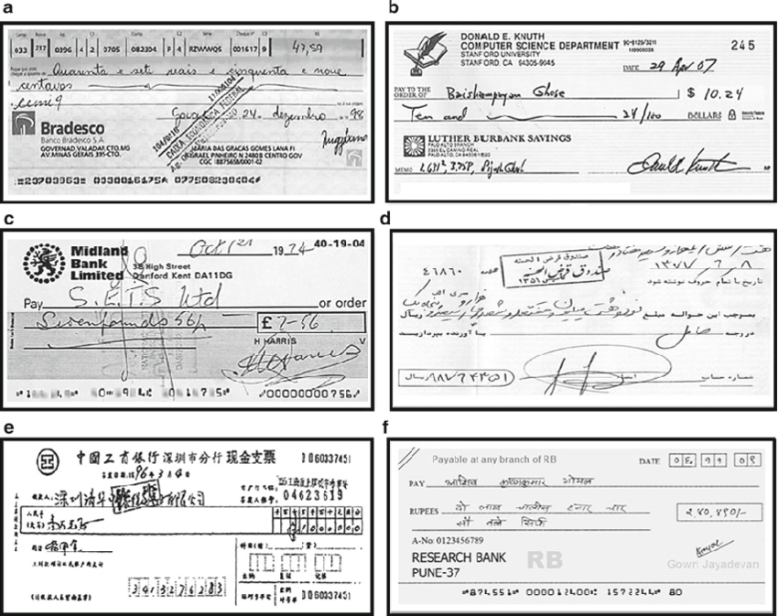

### **Banking**

People write cheques on a regular basis and cheques still play a major role in most non-cash transactions. In many developing countries, the present cheque processing procedure requires a bank employee to read and manually enter the information present on a cheque and also verify the entries like signature and date. As a large number of cheques have to be processed every day in a bank a handwriting text recognition system can save costs and hours of human work

### **Online Libraries**

Huge amounts of historical knowledge is being digitized by uploading the image scans for access to the entire world. But this effort is not very useful until the text in the images can be identified which can be indexed, queried and browsed. Handwriting recognition plays a key role in bringing alive the medieval and 20th century documents, postcards, research studies etc.

**Result**

Although there have been significant developments in technology which help in better recognition of handwritten textbook, HTR is a far from a answered problem compared to OCR and hence isn't yet considerably employed in assiduity. nonetheless with the pace of technology elaboration and with the preface of models like mills, we can anticipate HTR models to come a commonplace soon. We discussed a NN which is able to recognize text in images. The NN consists of 5 CNN and 2 RNN layers and outputs a character-probability matrix. This matrix is either used for CTC loss calculation or for CTC decoding. An implementation using TF is provided and some important parts of the code were presented. Finally, hints to improve the recognition accuracy were given. The use of binarization features along with the neural network classifier employing back-propagation algorithm delivers outstanding classification accuracy of 77.69 %. Training sample quality, feature extraction technique and the classifier are the main factors deciding the accuracy of the recognition system. All these techniques can be refined because a scope of improvement is always there. In future, a combination of binarization features with some other type of features such as Projection profile Features, can be investigated in the recognition experiment. Apart from MLP classifier, other classifiers such as RBF, HMM, SVM etc. can also be examined in future.